TASK-3

introduction

This website can be use by mobile, laptop or any device and by clear hierarch and user flow to match the need of the target audience. Evidence in the form of screenshots, test results, and notes on changes made after testing is included throughout this report.

Browser Testing
The website was tested on three browsers:

Google Chrome (latest version)

Mozilla Firefox (latest version)

Microsoft Edge (latest version)

- Responsive Layout Testing (Mobile, Tablet, Desktop)
Testing was done using Chrome Developer Tools across:
- Mobile (375px width – iPhone X)
- Tablet (768px width – iPad)
- Desktop (1366px width)

Device | Layout Behaviour | Readability | Navigation | Issues Found
Mobile | Responsive but images resized too large | Good | Working | Needed image max-width fix
Tablet | Good | Good | Working | No issues
Desktop | Fully functional | Perfect | Smooth | No issues

3.2 Changes Made
- Added responsive image rule:
- img {
- max-width: 100%;
- height: auto;
- }

@media (max-width: 480px) {
.container {
padding: 10px;
}
}

4. Accessibility Evaluation
Accessibility was checked using:
- Wave Web Accessibility Tool
- Manual checks based on WCAG guidelines
5. HTML & CSS Validation
Validation was performed using:
- W3C HTML Validator
- W3C CSS Validator
5.1 HTML Validation Result
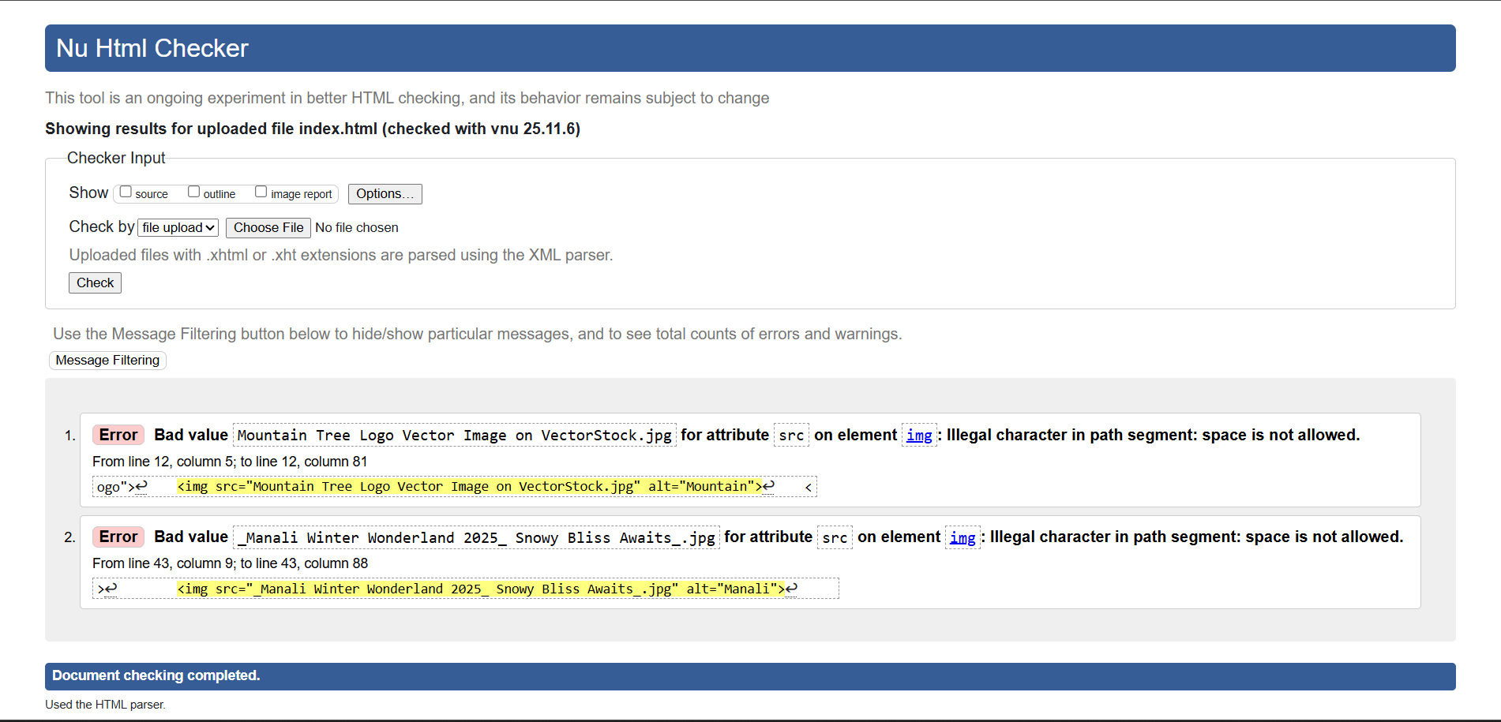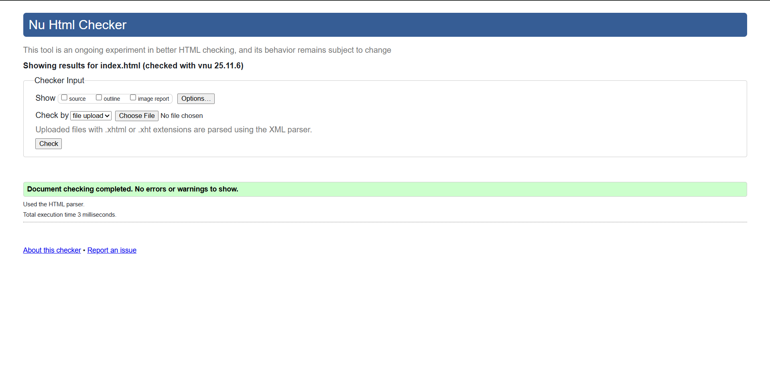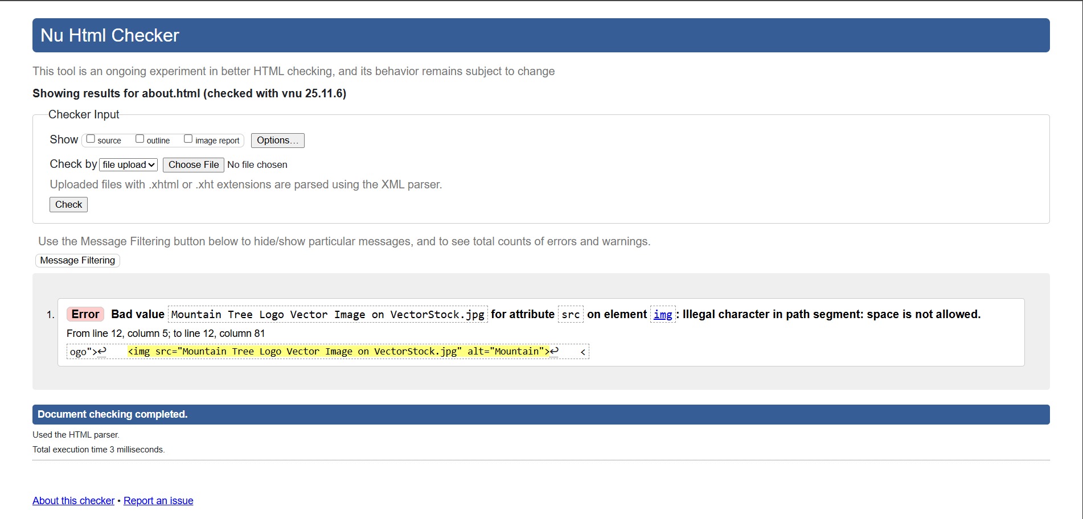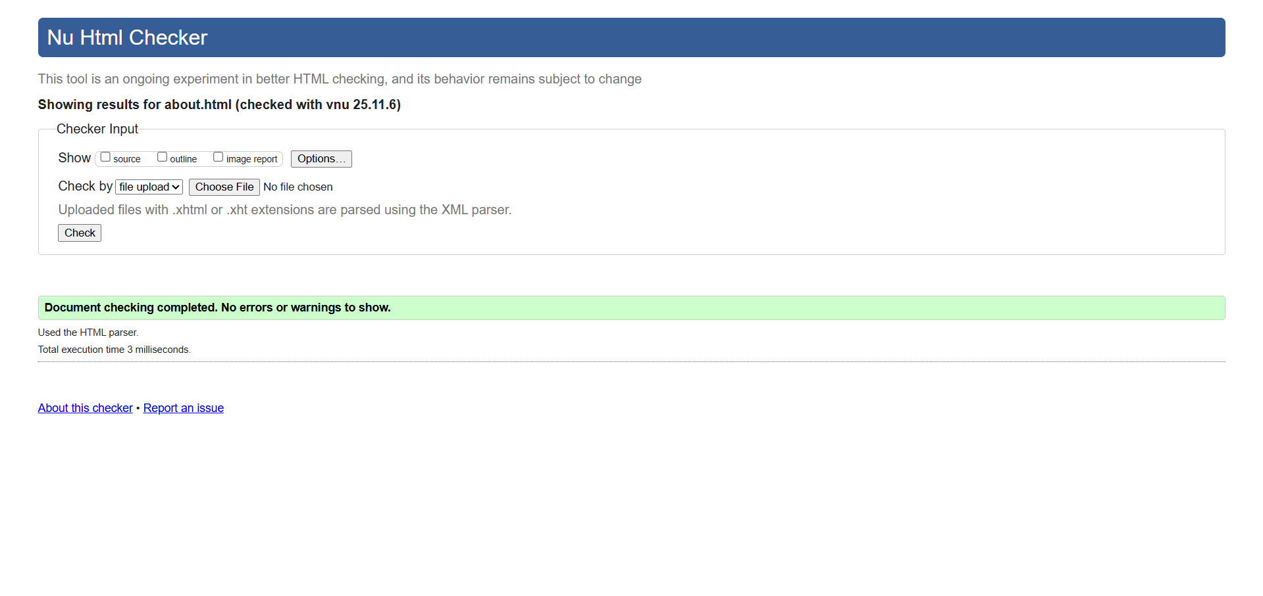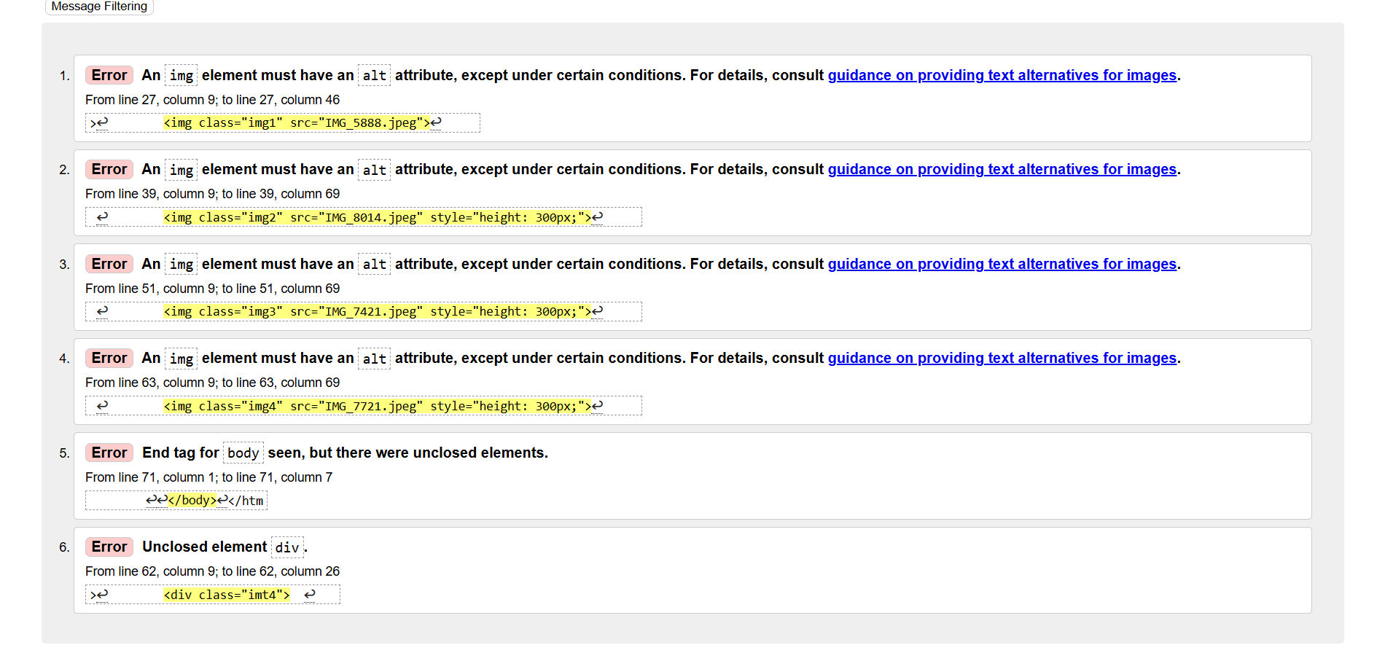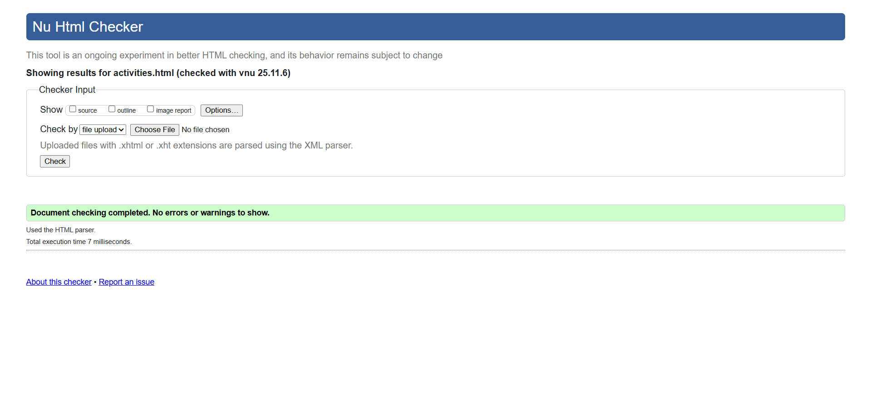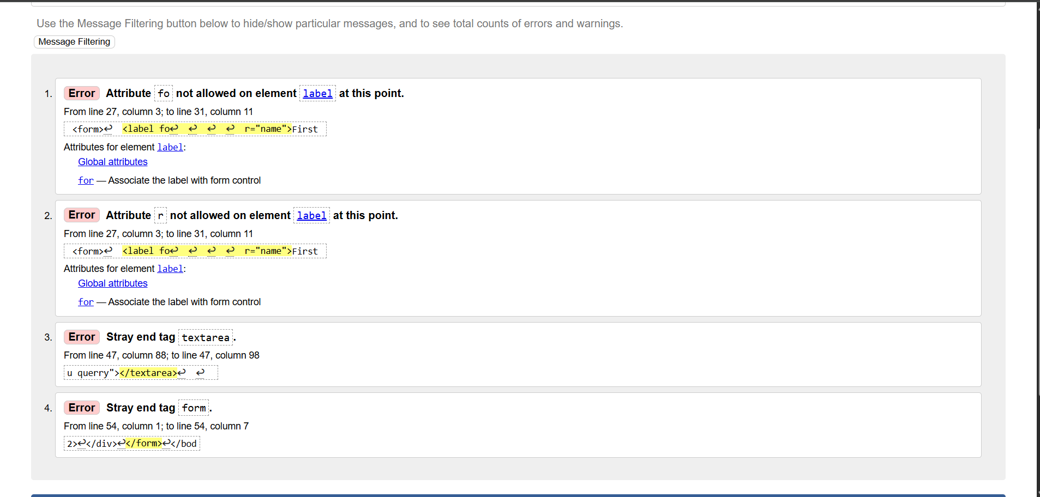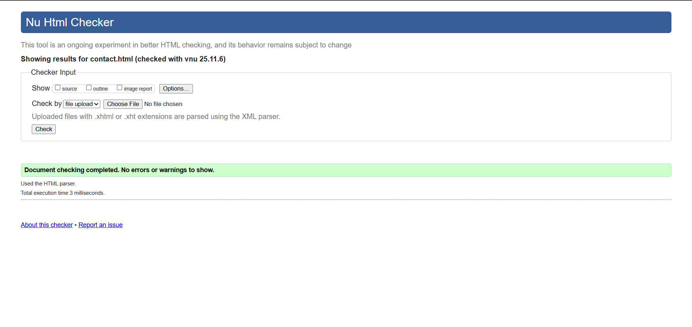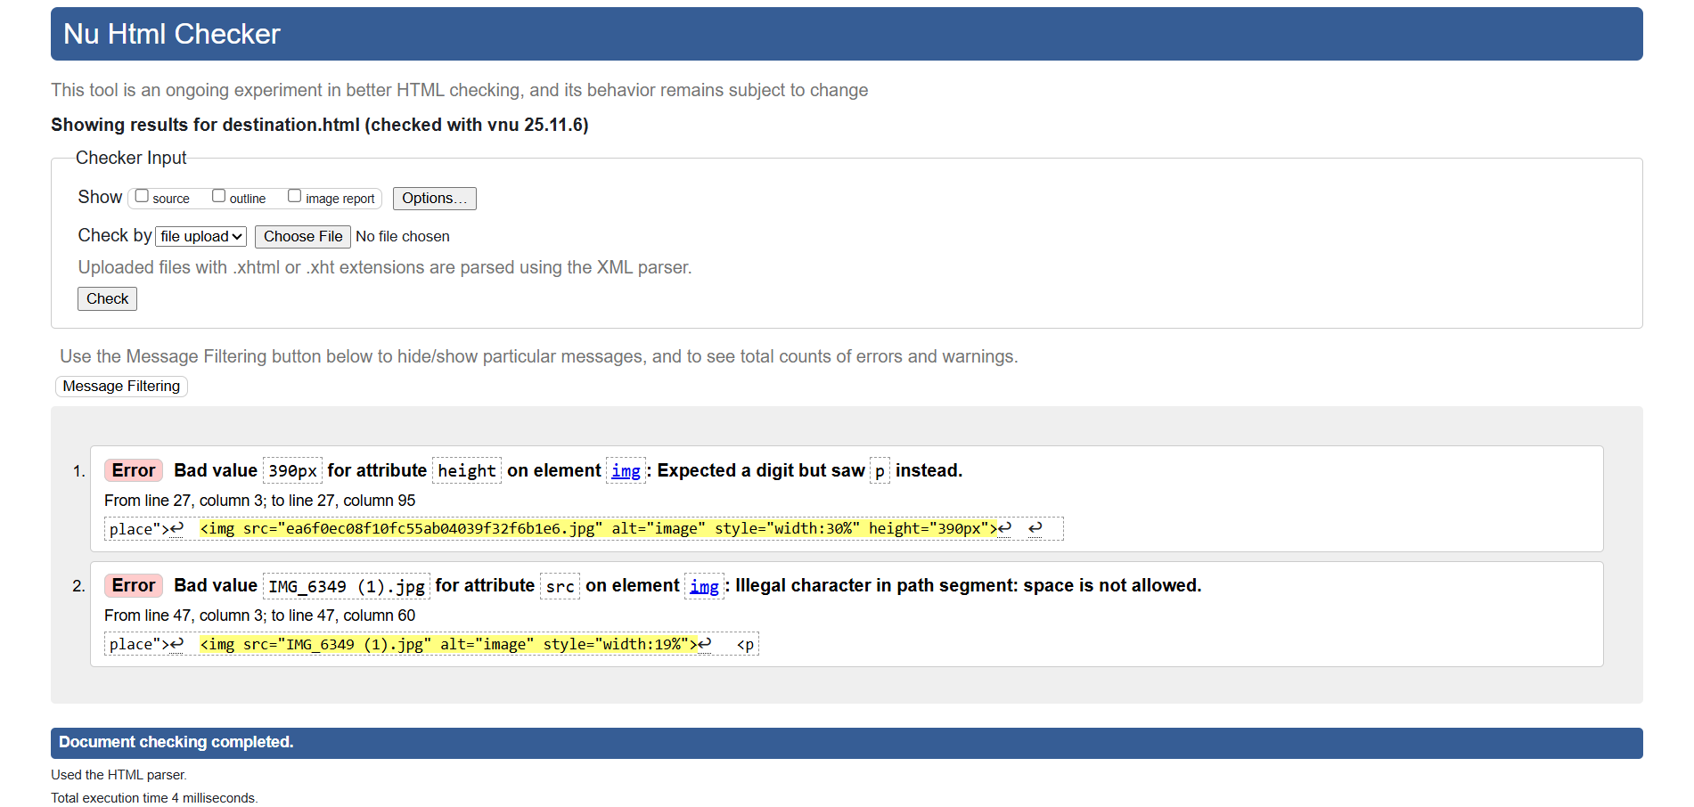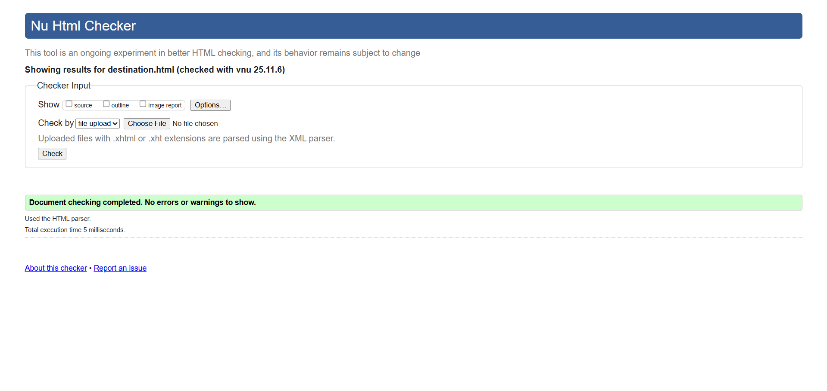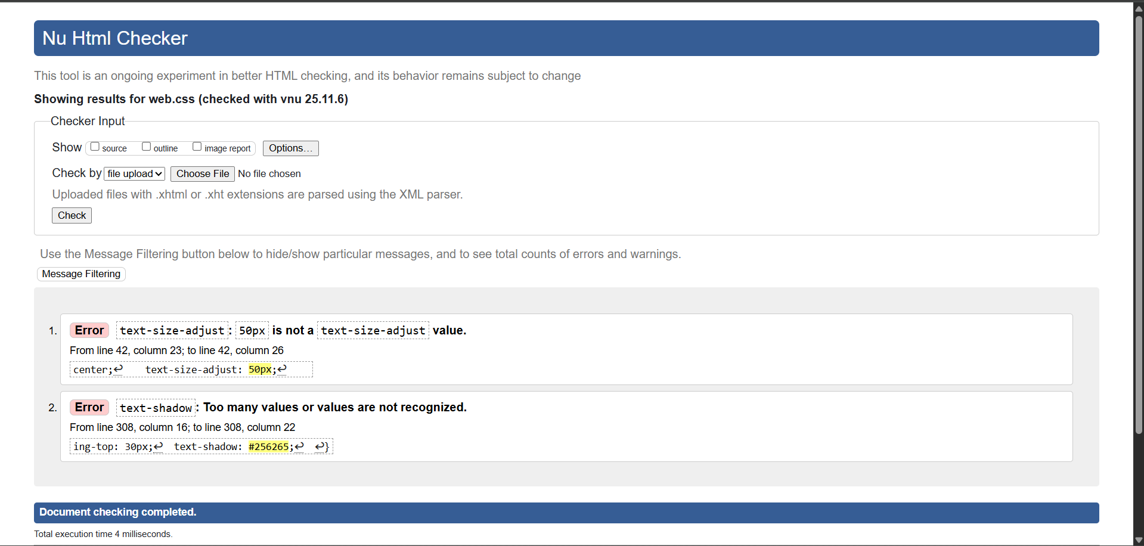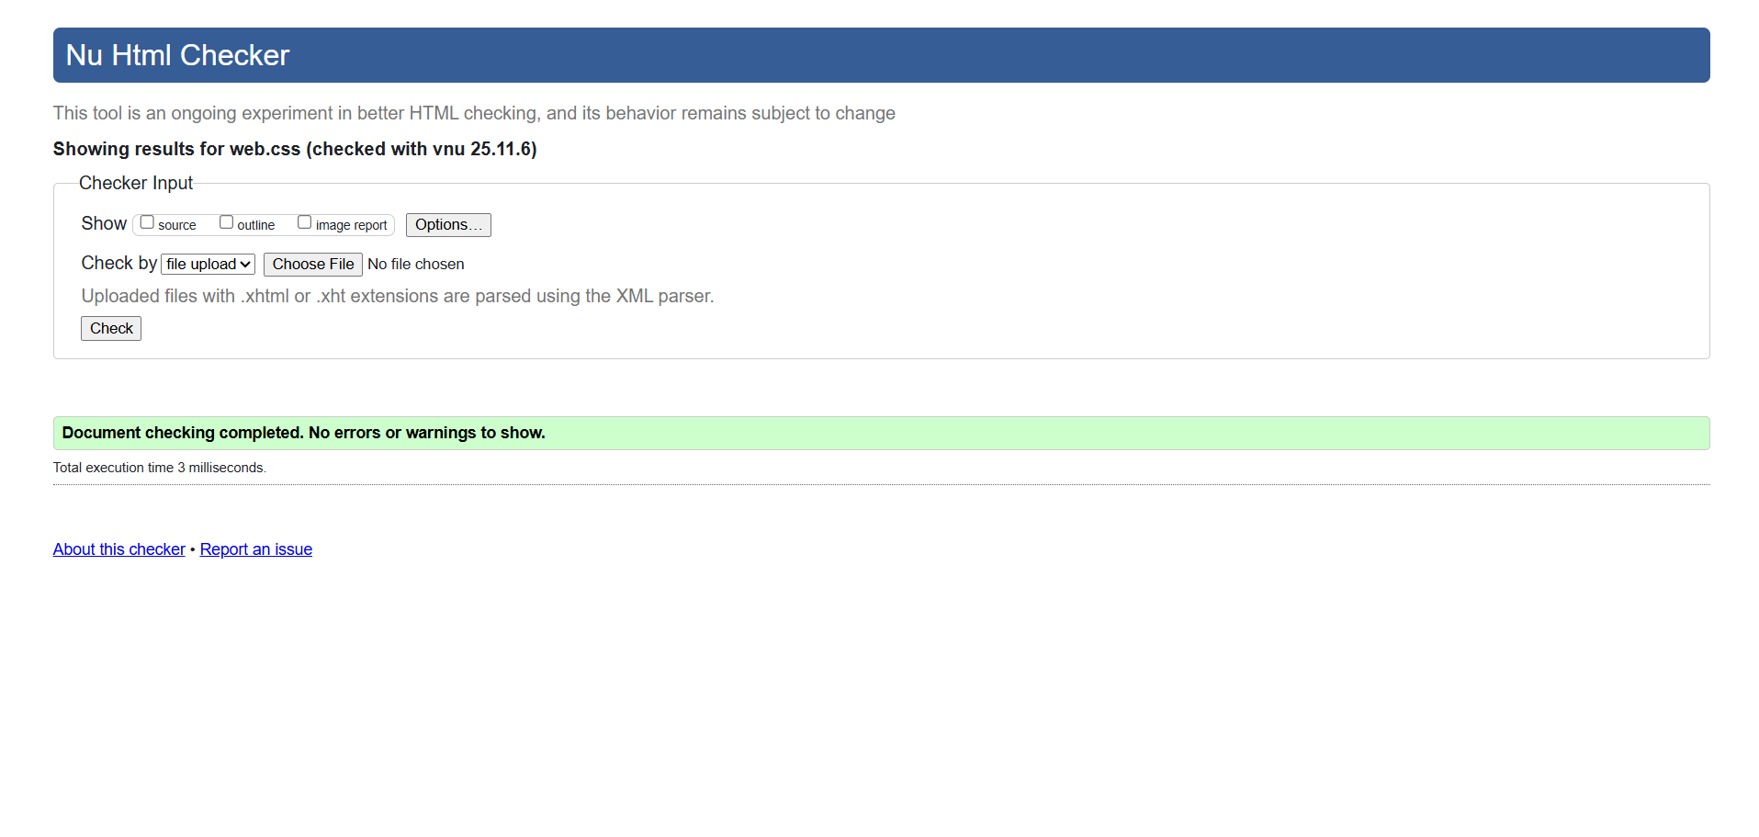
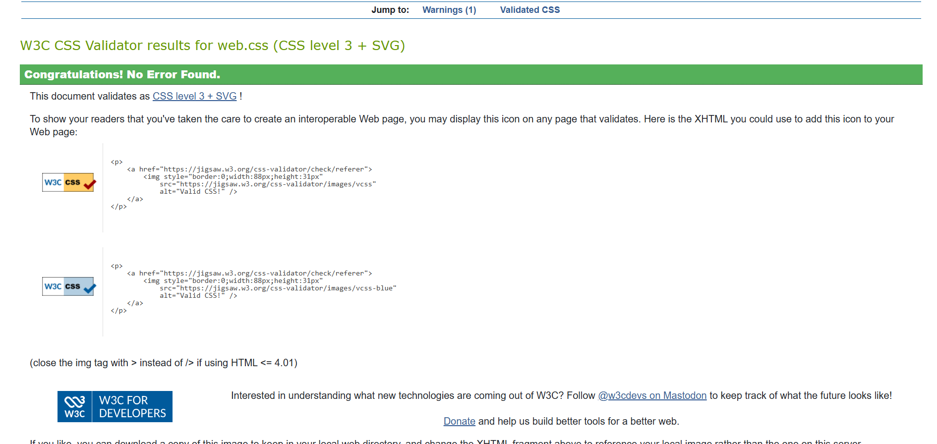

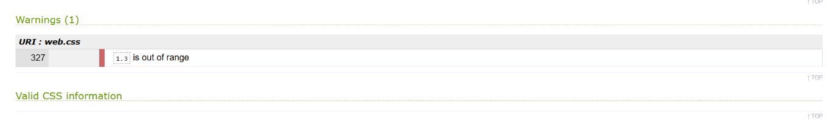

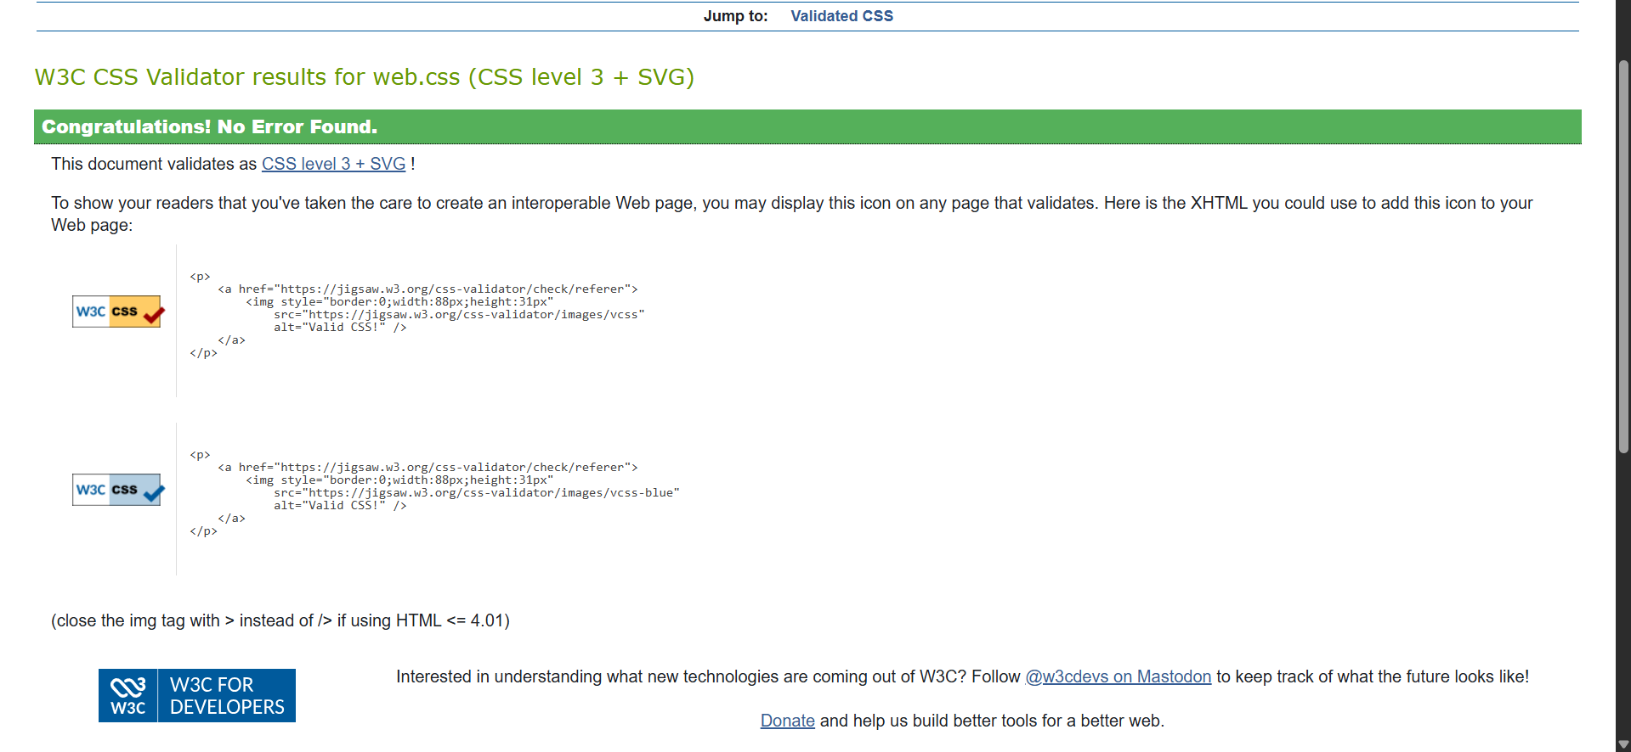

6. Overall Evaluation
After performing usability, accessibility, and validation testing, the website now provides:
- Consistent layout across major browsers
- Fully responsive design on all major screen sizes
- Improved accessibility with alt text and form labels
- Valid HTML and CSS with no remaining critical issues
The testing process helped identify and correct subtle design and usability issues, resulting in a more professional and user-friendly tourism website.

7. References
(Insert these only if used — remove unused ones)
- W3C HTML Validator
- W3C CSS Validator
- WebAIM Contrast Checker
- Wave Web Accessibility Tool

